A Short Report 2
Late July I received a request from the president of the Outer Eastern Metro Vietnam Veterans Association, Mr Amat (Aff) Binoore, as to whether I would be amenable to being their guest speaker for the forthcoming Vietnam Veterans Day Dawn Service at Boronia RSL, home of our immediate past Treasurer, Carl Sorensen.
Aff had asked me to prepare something about the RANs involvement in Vietnam, and that, to the best of his knowledge and belief, in the 20 years since the inception of this branch of the VVAA they had never had anyone speak about the RANs part in the conflict.
In attendance on the day was the State Minister for the Arts, Member for Bayswater, Ms Heidi Victoria MP, and the State Minister for Higher Education and Training, Member for Ferntree Gully, Mr Nick Wakeling MP, and 40-45 members of the Outer Eastern Metro VVAA, including our very own John Ferguson and Fred Mcleod-Dryden. Although some bright spark said that Fred turned up just in time for the excellent ‘Gunfire’ breakfast prepared by the members of the Boronia RSL.
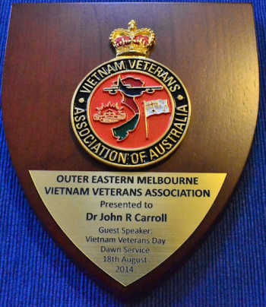
The talk I gave went for 15 minutes, the text of which I will attach to this report for the information of our members. It appeared to be well received, and on completion I was presented with a plaque and a bouquet of flowers for my wife, which, I can tell you from a personal point of view, was very much appreciated.
I guess why I am reporting on this occasion is to reinforce the direction I would prefer us to adopt during my tenure as President of our Association and that is, to have more involvement with organisations with the same or similar interests as our own. It can only be to our mutual benefit. This doesn’t mean we forget out past, we can do both. Honour those who have gone before us, while still looking after our own.
Regards to all
Dr John Carroll
President

